Assignment 11

Name: Prathmesh M. Sarwade

PRN: 22510050

Batch: T3

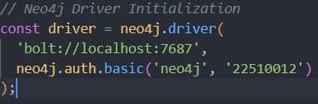

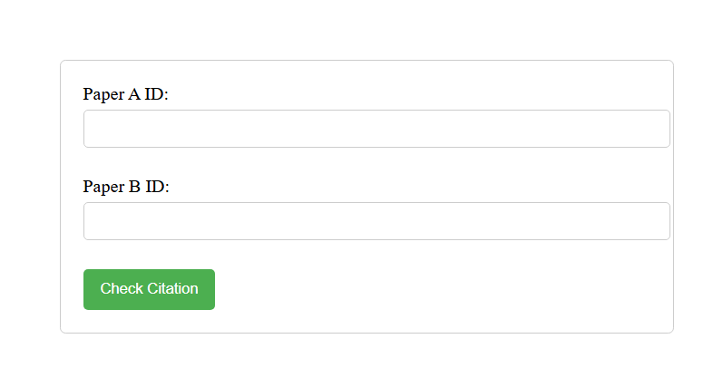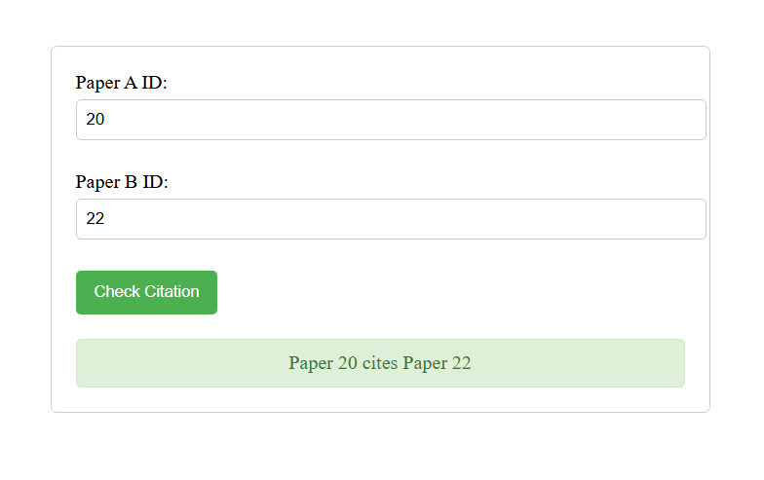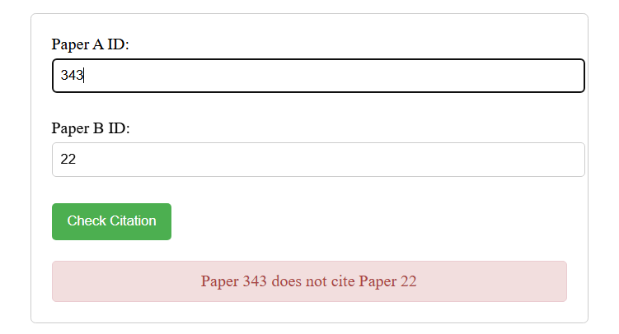

Neo4j setup:

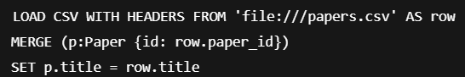



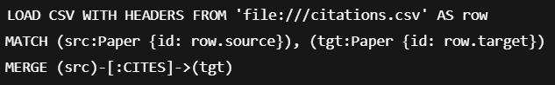

MATCH (a:Paper)-[r:CITES]->(b:Paper)

RETURN a, r, b

LIMIT 50;

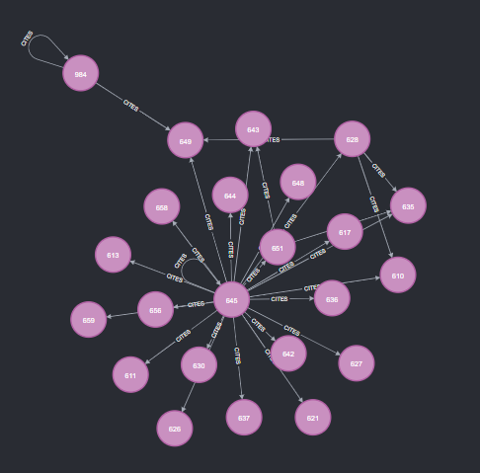

MATCH (a:Paper)-[r:CITES]->(b:Paper)

RETURN a.id AS SourcePaper, b.id AS TargetPaper

LIMIT 50;

